#### Final-Project Report of Bachelor of Computer Engineering

**Road Maintenance Complaint System**



#### **Submitted by:**

|  |  |
| --- | --- |
| **Aashutosh Sapkota** | **BEC [2077-01]** |
| **Hom Bdr. Pathak Kshetri** | **BEC [2077-16]** |
| **Abhishek Sharma** | **BEC [2077-02]** |
| **Rajeev Paudel** | **BEC [2077-24]** |

**United Technical College**

**Department of Computer Engineering**

**Affiliated to Pokhara University, Nepal**

#### September, 2023

Second Year Project Report for the Degree of Bachelor of

Computer Engineering

**Road Maintenance Complaint System**

**Supervised by: Mr. Ramji Subedi**

A second-year project report submitted in partial fulfillment of the requirements for the degree of bachelor of computer engineering.

#### **Submitted by:**

|  |  |
| --- | --- |
| **Aashutosh Sapkota** | **BEC [2077-01]** |
| **Hom Bdr. Pathak Kshetri** | **BEC [2077-16]** |
| **Abhishek Sharma** | **BEC [2077-02]** |
| **Rajeev Paudel** | **BEC [2077-24]** |

**United Technical College**

**Faculty of Science and Technology**

**Pokhara University, Nepal**

September, 2023

# Dedication

This project is dedicated to all those who travel the roads each day, navigating through challenges and obstacles. A special dedication to the teacher who provided invaluable guidance and to our department for assigning such a humble and supportive supervisor, enabling us to successfully complete this project work. To all the individuals who have worked tirelessly to support and guide us in completing this project. This project is a tribute to your collective efforts and a commitment to a safer and smoother road ahead.

# Declaration

We hereby affirm that this research study, titled "**Road Maintenance Complaint System**" represents the culmination of our original work. Any relevant prior research conducted by other scholars has been duly acknowledged.

We assume full responsibility for the precision and authenticity of all data and information contained within this study.

Names of the Students:

|  |
| --- |
| **Aashutosh Sapkota** |
| **Hom Bdr. Pathak Kshetri** |
| **Abhishek Sharma** |
| **Rajeev Paudel** |

Date: September 22, 2023

# Recommendation

This is to certify that the project work titled " **Road Maintenance Complaint System** prepared and submitted by **Aashutosh Sapkota**, **Hom Bdr. Pathak Kshetri**, **Abhishek Sharma**, and **Rajeev Paudel** in partial fulfillment of the requirements for the degree of Bachelor of Engineering (BE) in Computer Science, awarded by Pokhara University, has been conducted under the supervision of **Mr. Ramji Subedi**.

We recommend the acceptance of this project by Pokhara University based on its comprehensive research, innovative approach, and successful execution.

Signature: ____________

Name of the Supervisor: Mr. Ramji Subedi

Date: September, 2023

# Certificate

This project entitled “**Road Maintenance Complaint System”** prepared and submitted by **Aashutosh Sapkota, Hom Bdr. Pathak Kshetri,** **Abhishek Sharma** and **Rajeev Paudel** have been examined by us and is accepted for the award of thedegree of Bachelor Engineering in Computer by Pokhara University.

Name of External:

Designation:

Organization:

Signature: ____________

Name of Supervisor: Mr. Ramji Subedi

Signature: ____________

Name of Principal: Prof. Keshab Datt Awasthi (Ph.D)

Organization: United Technical College

Signature: ____________

Date: September, 2023

Abstract

Road accidents are incidents that occur on roads involving vehicles, resulting in damage to property, injuries, or even loss of life. These accidents can be caused by various factors, including human error, such as speeding, and reckless driving, as well as road conditions. With the recognition of such a problem, a web-based application aimed to solve the issue of poor road conditions is created.

The Road Complaint Maintenance System aims to empower citizens to actively participate in improving road safety. Everyone has the power to report road conditions and maintenance requirements to the government. The project's goal is to develop a transparent and efficient system through which the public and government organizations may collaborate to improve road quality and prevent accidents. The system will be built using HTML, CSS, JavaScript, SQL, and PHP, ensuring a user-friendly interface and efficient data Management. The project is expected to take 10 weeks.

**KEYWORDS**: *Complaint, Register, Problem, Action, Acknowledgment, Authorized, Web, etc.*

Acknowledgement

We would like to express our heartfelt gratitude to all those who have contributed to the successful completion of this project.

First and foremost, we are deeply thankful to our project advisor, Mr. Ramji Subedi, Er. Sudeep Thapaliya, Er. Sahit Baral for their unwavering guidance, invaluable insights, and constant encouragement throughout this journey. Their expertise and mentorship played a pivotal role in shaping the direction and quality of this project.

We extend our appreciation to the faculty members of the United Technical College Department of Computer Engineering for their dedication to imparting knowledge and for providing us with a conducive learning environment.

We are also indebted to our teammates who worked tirelessly, sharing their knowledge and experiences. Our collaborative efforts were instrumental in achieving the project's goals.

We extend our gratitude to our family for their unwavering support and understanding during the demanding phases of this project.

Lastly, we would like to express our thanks to all the resources, books, and online materials that were instrumental in enhancing our understanding and knowledge in the field of computer engineering.

This project would not have been possible without the collective efforts and support of all these individuals and resources. I am truly grateful for their contributions.

AKAR

United Technical College

September,2023

Table of Contents

Dedication iii

Declaration iv

Recommendation v

Certificate vi

Abstract vii

Acknowledgement viii

Table of Contents ix

List of Figures 13

List of Tables 14

Acronyms and Abbreviation 15

Chapter 1: Introduction 1

1.1 Background 1

1.2 Problem statement 2

1.3 Objectives 3

1.4 Scopes and Features 3

1.5 Application 4

1.6 Feasibility Analysis 4

1.6.1 Economic Feasibility 4

1.6.2 Technical Feasibility 5

1.6.3 Operational Feasibility 5

1.6 System Requirements 5

1.7 .1 Software Requirements 6

1.7.2 Hardware Requirements 6

Chapter 2: Literature Review 7

2.1 Case study 7

2.1.1 FixMyStreet 7

2.1.2 Roadify 7

2.1.3 Street Bump 8

2.2 Status of Road Maintenance in Nepal 9

Chapter 3: Methodology 10

3.1 Flow of project 11

3.1.1. Concept and Initiation 11

3.1.2. Definition and planning 12

3.1.3. Software Used 12

3.1.4 Development 13

3.1.4. Launch and Execution 14

3.1.5. Performance and Control 14

3.2 System design 15

3.2.1 System flow Diagram 15

3.2.2 E-R diagram 17

3.2.3 DFD (Data Flow Diagram) 18

3.2.4 Use case Diagram 20

3.2.5 Software Development Model 21

3.3 Testing and maintenance 22

Chapter 4: Time Estimation 23

Chapter 5: Results and Discussion 25

5.1 Output 25

5.2 Accomplishments: 25

5.4 Challenges Encountered: 30

5.5 Limitation 31

5.6 Budget Estimation 31

Chapter 6: Conclusion & Future Enhancement 33

6.1 Conclusion: 33

6.2 Scope of Future Enhancement: 33

References 35

Appendix : 37

List of Figures

3.1: Flow of project, Road Complaint Maintenance System 11

3.2.1: System Flow Diagram 16

3.2.2: E-R Diagram for Road Complaint Maintenance System 17

3.2.3: Level 0 Data Flow Diagram 18

3.2.3: Level 1 Data Flow Diagram 19

3.2.3: Level 2 Data Flow Diagram 19

3.2.4: Use case Diagram 20

3.2.5: WaterFall Model 21

5.2(B): User Interface Design 26

5.2(C): User Registration Module and Secure Login 27

5.2(D): User Dashboard 27

5.2(E): Database Design 28

5.2(F): Admin login interface 28

5.2(G): Password reset with email verification interface 29

5.2(H): Admin Dashboard 30

List of Tables

Table 1: Gantt chart of the project 23

Table 2: Budget Estimation 32

Acronyms and Abbreviation

|  |  |  |
| --- | --- | --- |
| CSS | : | Cascading Style Sheets |
| DFD | : | Data Flow Diagram |
| ERD | : | Entity Relationship Diagram |
| GB | : | Gigabytes |
| GDP | : | Gross Domestic Product |
| HTML | : | Hypertext Markup Language |
| HTTP | : | Hypertext Transfer Protocol |
| JS | : | JavaScript |
| MB | : | Mega-Bytes |
| PHP | : | Hypertext Preprocessor |
| RAM | : | Random Access Memory |
| RDBMS | : | Relational Database Maintenance System |
| SQL | : | Structured Query Language |
| VS Code | : | Visual Studio Code |
| XAMPP | : | Cross-Platform, Apache, MySQL, PHP and Pearl |
| XML | : | Extensible Markup Language |

# Chapter 1: Introduction

## Background

Roads play a crucial role in the transportation system of Nepal, serving as the primary mode of transport. In the past, roads were constructed without adequate consideration for future maintenance needs, resulting in a significant loss of road assets. On average, 5 km of road per year per 100 km of roads built were being lost. Even higher-standard roads, supported by donors, experienced a similar rate of decline. From 1988 to 1992, the length of roads in "poor condition" nearly doubled, and the overall condition of the major road network deteriorated rapidly, with approximately 180 km of good road being lost annually [1].

Unfortunately, the situation is further aggravated by the increasing number of road accidents and fatalities. The declining road quality, coupled with the growing volume of vehicles on the roads, has led to a surge in fatal accidents nationwide. According to the World Health Organization (WHO) report of 2013, more than three thousand people lose their lives daily due to road traffic accidents globally, with approximately 1.3 million annual fatalities. The alarming combination of poor road conditions and rising accident rates emphasize the urgent need for research to address these critical issues [2].

By investigating the factors contributing to road deterioration, exploring effective road maintenance strategies, and examining measures to enhance road safety, this proposed research aims to make significant contributions toward improving Nepal's road infrastructure and reducing the number of road accidents and fatalities. The deteriorating road conditions have contributed to an increase in accidents. Factors such as potholes, inadequate signage, poor road markings, and lack of maintenance have created hazardous conditions for drivers, pedestrians, and other road users. The combination of substandard road infrastructure and unsafe driving behaviors has resulted in a high number of road accidents, injuries, and fatalities in Nepal [3].

To address these challenges, the proposed solution of the Road Complain Maintenance System offers a web-based application to tackle the problem of poor road conditions. The system aims to empower citizens by providing them with a platform to actively participate in improving road safety. Through this system, individuals can report road conditions and maintenance requirements to the government, ensuring that concerns regarding road quality and safety are promptly addressed. The key objective of the Road Complain Maintenance System is to establish a transparent and efficient collaboration between the public and government organizations. By leveraging the power of citizen engagement, the system aims to enhance the quality of roads and prevent accidents. It provides a mechanism for citizens to report issues such as potholes, damaged signage, inadequate lighting, or any other factors that contribute to unsafe road conditions. These reports can then be reviewed and addressed by the relevant authorities responsible for road maintenance [4].

Road Complain Maintenance System offers a promising solution to the challenges faced in road Maintenance and the escalating accident rates in Nepal. By facilitating citizen engagement, promoting transparency, and enabling efficient collaboration between the public and government organizations, the system has the potential to significantly improve road conditions and enhance road safety. Through its implementation, Nepal can work towards achieving a safer and more sustainable road network [5].

## Problem statement

The roads in Nepal are currently plagued by several issues, including poor maintenance, inadequate infrastructure, and lack of timely repairs. However, one of the significant challenges exacerbating these problems is the absence of a dedicated governing body or mechanism to effectively listen to public concerns and address the road-related issues reported by citizens. The limited government budget allocations and historical negligence of future maintenance needs during road construction have resulted in deteriorating road conditions. The road network is facing a rapid decline, with an increasing length of roads falling into the category of "poor condition." These substandard road conditions pose significant risks to road users, leading to a surge in accidents, injuries, and fatalities [6].

The lack of an established framework for public participation and road complaint Maintenance further compounds the problem. Without a dedicated platform for citizens to report road conditions and maintenance requirements, concerns raised by the public often go unheard or unaddressed. This lack of responsiveness not only undermines public confidence but also perpetuates the cycle of poor road conditions and unsafe infrastructure [7].

We would solve this problem by implementing a user-friendly road Maintenance system which can help to address the challenges in road Maintenance. This system enables real-time monitoring, public reporting of road issues, streamlined maintenance processes, and improved communication between the government and the public.

## Objectives

The objectives of the proposed system are as follows:

1. To create a complaint dashboard for efficient monitoring, analysis, and decision-making in road maintenance.
2. To empower citizens by providing them with a platform to actively participate in road improvement.
3. To facilitate identifying areas requiring maintenance, repairs, or infrastructure upgrades for safer and more reliable road networks.

## Scopes and Features

## Complaint submission: Users can report road complaints through the system's interface.

## Government collaboration: Facilitating collaboration between users and government agencies.

## Data Maintenance and analysis: Efficiently store and analyze complaint data.

## Mobile compatibility: Access and report complaints through mobile devices.

## Scalability: Capable of handling a large volume of complaints and future growth.

## System maintenance: Regular updates and enhancements.

## Public participation: Encouraging citizen involvement in road improvement.

## Road network improvement: Contributing to safer and more reliable road networks.

## Application

The main concept of this website is to establish a platform that empowers citizens to actively participate in enhancing road safety and infrastructure. Through this platform, individuals can report road complaints, such as poor road conditions, inadequate signage, or other hazards. Also, to improve the overall quality and safety of the road network.

## 1.6 Feasibility Analysis

Feasibility analysis is a process of evaluating the practicality and likelihood of success of a proposed project or venture. It involves assessing the economic, technical, and operational feasibility of the project.

## 1.6.1 Economic Feasibility

The economic feasibility of a road maintenance complaint management system (RMCS) can be assessed by comparing the costs and benefits of the system.

* **Development costs:** The estimated costs for development, implementation, and ongoing maintenance are within the allocated budget.
* **Implementation costs:** This includes the cost of training staff and deploying the system.
* **Maintenance costs:** This includes the cost of bug fixes and updates.

**Major Benefits:**

* **Reduced costs of road maintenance:** The system can help to identify and address road maintenance issues more quickly and efficiently, which can lead to reduced costs in the long run.
* **Improved customer satisfaction:** The system can make it easier for citizens to report road maintenance issues and track their progress, which can lead to improved customer satisfaction.
* **Increased transparency:** The system can help to increase transparency in the road maintenance process, which can lead to improved public trust.

## 1.6.2 Technical Feasibility

The technical feasibility analysis demonstrates that the development and implementation of the "Road Maintenance Complaint Management System" is both practical and attainable.

**Technology Assessment:** The required technology components, including hardware and software, are readily available and well-established in the market. There are no significant technological barriers that would impede the project's progress.

**Skills and Expertise:** Our project team possesses the necessary technical skills and expertise to design, develop, and maintain the system. In cases where specialized knowledge is required, we have identified potential team members or external consultants with the requisite skills.

## 1.6.3 Operational Feasibility

The operational feasibility analysis affirms that the "Road Maintenance Complaint Management System" can be smoothly integrated into existing operations and effectively used by all stakeholders.

**User Acceptance:** Extensive user feedback and input from road maintenance personnel, citizens, and other relevant stakeholders have been gathered and incorporated into the system's design.

**Operational Processes:** The system seamlessly integrates with existing operational processes and workflows. It streamlines the management of road maintenance complaints, optimizes resource allocation, and enhances communication between various departments and stakeholders.

## System Requirements

For our Road Complaint Maintenance System project, the hardware and software requirements are as follows:

## .1 Software Requirements

1. **Operating System:** Compatible with various operating systems, including Windows, macOS, Android, and iOS.
2. **Web Browsers:** Support for popular web browsers such as Google Chrome, Mozilla Firefox, Microsoft Edge, and Safari.
3. **Responsive Design:** The system should be designed and developed using responsive web design principles to ensure optimal user experience across different devices and screen sizes.
4. **Cross-Browser Compatibility:** The system should be compatible with multiple web browsers to ensure consistent functionality and appearance.

## 1.7.2 Hardware Requirements

1. **Mobile Devices:** Any smartphone or tablet with an internet connection and a modern web browser.
2. **Computers:** Any desktop or laptop computer with an internet connection and a modern web browser. The system should be compatible with both Windows and macOS operating systems.

## By ensuring compatibility with a wide range of devices and operating systems, our Road Complaint Maintenance System can be accessed and used seamlessly by users on their smartphones, computers, and other devices.

# Chapter 2: Literature Review

## Case study

## 2.1.1 FixMyStreet

FixMyStreet is an online platform that has revolutionized the way citizens engage with their local communities to address infrastructure problems. Launched in 2007, FixMyStreet provides a user-friendly website and mobile application that enables citizens to report various issues, such as potholes, broken streetlights, and graffiti, by pinpointing the problem's location on a map [8].

The primary objective of FixMyStreet is to empower citizens and establish a direct and efficient channel of communication with local government authorities. By utilizing the platform, citizens can actively participate in improving their community's infrastructure and contribute to the prompt resolution of reported issues. One of the key features of FixMyStreet is its user-friendly interface, making it easy for individuals to report problems seamlessly. Through the website or mobile app, users can accurately pinpoint the location of the issue on a map, facilitating swift identification and resolution. FixMyStreet promotes transparency and collaboration by providing real-time updates to users. Citizens can track the progress of their reported issues and receive updates on their resolution status, fostering a sense of engagement and accountability [9].

FixMyStreet's data collection and analysis have also proven valuable. By analyzing the reported issues, local authorities can gain insights into patterns, prioritize repairs based on severity, and allocate resources efficiently. This data-driven approach enables evidence-based decision-making and enhances resource utilization. FixMyStreet has transformed the way citizens engage with local authorities, fostering transparency, accountability, and collaborative problem-solving [10] .

## 2.1.2 Roadify

Roadify is an innovative application that has revolutionized the way road users access and share real-time information about road conditions, traffic congestion, and incidents. This mobile app provides a platform for users to report and communicate road-related updates, contributing to a collective pool of data that enhances awareness and assists drivers in making informed decisions [11].

The main concept behind Roadify is to create a community-driven network where users actively participate in sharing real-time road information. By utilizing the app, users can report road hazards, accidents, or road closures, providing valuable insights to other road users and relevant authorities. The success of Roadify can be attributed to several factors. The app harnesses the collective power of its user base, creating a vast network of real-time road information. This network effect enhances the accuracy and reliability of the reported information, benefiting all users who rely on the app for road updates.

Additionally, Roadify leverages data-driven insights to enhance the overall road experience. The app collects and analyzes user-generated data, enabling authorities to identify traffic patterns, areas prone to accidents, and infrastructure improvements. This data-driven approach supports evidence-based decision-making for road planning and Maintenance. Roadify enhances road safety and empowers individuals to make informed decisions while traveling [12].

## 2.1.3 Street Bump

Street Bump is an innovative case study that focuses on leveraging technology to improve road conditions. Developed by the City of Boston, Street Bump is a smartphone application that allows citizens to contribute to the identification of potholes and other road defects. The app uses the accelerometer and GPS sensors in smartphones to detect and record road irregularities as users drive along city streets. When a bump or pothole is detected, the app automatically sends the data, including the location and severity of the road issue, to the city's Department of Public Works [13].

The case study of Street Bump highlights the power of citizen engagement and crowdsourcing in gathering valuable data for road maintenance and repairs. By involving the community in reporting road defects, the city can prioritize, and address maintenance needs more efficiently. This innovative approach not only improves the overall condition of the road network but also enhances transparency and accountability in government operations [13].

The success of Street Bump lies in its ability to harness the ubiquity of smartphones and engage citizens as active participants in the maintenance and improvement of city infrastructure. The data collected through the app helps the city identify areas in need of repair, allocate resources effectively, and provide a safer and smoother driving experience for residents and visitors. Moreover, the case study demonstrates the potential of technology-driven solutions in solving real-world challenges, transforming the way governments and communities collaborate for the benefit of all [13].

## Status of Road Maintenance in Nepal

There is little doubt that roads are arteries of development and can add to the overall quality of citizens’ lives. Sadly, if you talk about public roads in Nepal, national highways, strategic road networks, city roads, feeder roads, district roads, or rural roads—most of them have been clogged and turned into perils. Further, countless potholes, poor drainage systems, yawning ditches, several mismanaged manholes and sinkholes as well as other road-related infrastructural breakdowns have perennially added to the public woes [1].

 At the eleventh hour of every fiscal year, the government speeds up various developmental projects at the cost of sustainable infrastructures. Our contractors can be seen carrying out many developmental activities–digging ditches, laying sewerage pipelines, constructing and blacktopping roads, and setting up other road-related critical infrastructures, among others. Hence, the under-utilization of the budget for the substantial part of the fiscal year and gush in expenditure towards the end only makes matters worse, thus leading to rickety, shoddy, and substandard road-related infrastructures [1].

The Department of Road (DoR) and the Department of Local Infrastructure Development and Agricultural Roads (DoLIDAR) are government agencies responsible for the planning, construction, maintenance, and improvement of public roads and related infrastructure. They have the necessary institutional support, policies, legal frameworks, technical expertise, and human resources to carry out these responsibilities effectively [2].

# Chapter 3: Methodology

It provides a structured framework for executing and completing a project. In the context of this project, the methodology outlines the step-by-step process that will be followed to design, develop, and deploy the Road Complaint Maintenance System. The methodology encompasses various stages, each stage involves specific tasks and activities that contribute to the successful implementation of the project. The methodology ensures a systematic and organized approach, allowing for efficient project Maintenance and the achievement of project objectives [14].

The purpose of project methodology is to allow for controlling the entire Maintenance process through effective decision making and problem solving, while ensuring the success of specific processes, approaches, techniques, methods and technologies.

In the proposed methodology there are 4 different stages which are flow of project, system design, software and hardware requirement and testing and maintenance.

## Flow of project

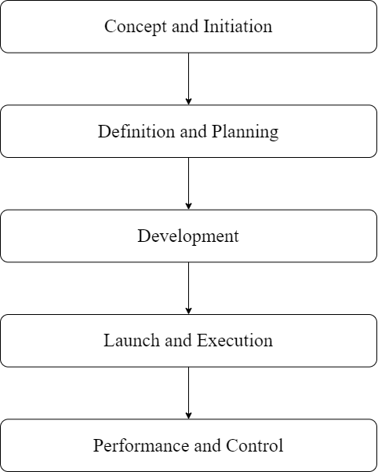

3.1: Flow of project, Road Complaint Maintenance System

(Group Study, 2023)

### Concept and Initiation

Before starting any project, it's important to collect and check if the requirements make sense. The project can continue if the requirements are feasible. During this phase, everyone involved in the project, like citizens and government officials, works together to gather all the necessary information needed to create and build the project. It's like putting together all the puzzle pieces to make sure we have everything we need. This way, the developers and designers can understand what needs to be done and create a system that solves road-related problems.

### Definition and planning

In our 'Road Complaint Maintenance System' project, our goal is to create a web application that facilitates the Maintenance of road complaints. The key components of the system include features for complaint submission by users, services for addressing the complaints, efficient administration and Maintenance of the system, and comprehensive tracking and resolution of reported road issues.

### Software Used

**1. XAMPP:** XAMPP is a widely used open-source software package that provides a complete web development environment. It stands for Cross-platform, Apache, MariaDB, PHP, and Perl. XAMPP includes all the necessary components to set up a local web server on your computer, including the Apache HTTP Server, MySQL database, PHP scripting language, and Perl programming language. It is a convenient solution for developers to create and test web applications locally before deploying them to a production environment. XAMPP is available for multiple operating systems and offers an easy-to-use interface for managing and configuring the server environment [15].

**2. Visual Studio Code:** VS Code is a popular source code editor developed by Microsoft. It is widely used by developers for various programming languages and platforms. VS Code offers a lightweight yet powerful environment with features like syntax highlighting, code completion, debugging, and Git integration. It supports a wide range of extensions that enhance functionality, allowing developers to customize their workflow. With its user-friendly interface and extensive community support, VS Code has become a preferred choice for many developers seeking a versatile and efficient code editor [16].

### 3.1.4 Development

In our "Road Complaint Maintenance System" project, we will utilize the following technologies:

**1. HTML:** HTML, which stands for HyperText Markup Language, is a markup language used for structuring and organizing web pages. It defines the elements and layout of a webpage, allowing us to create the basic framework of our application. By using HTML, we can arrange content, insert images, create links, and define the overall structure of our web pages [17].

**2. CSS:** CSS, short for Cascading Style Sheets, is a style sheet language used to control the presentation and appearance of web pages. It enables us to define styles, such as colors, fonts, layouts, and spacing, to enhance the visual appeal and user experience of our application. With CSS, we can create consistent and visually appealing designs across multiple web pages [18].

**3. JavaScript:** JavaScript is a programming language that adds interactivity and dynamic functionality to web pages. It allows us to create interactive elements, validate user inputs, handle events, and update content in real time. With JavaScript, we can implement features that respond to user actions, enhance the user interface, and make our application more engaging and user-friendly [19].

**4. PHP:** PHP is a server-side scripting language designed for web development. It enables us to handle server operations, process user inputs, and interact with databases. PHP is widely used for creating dynamic web pages, managing sessions, and generating content on the fly. In our project, we will utilize PHP to handle road complaints, manage user services, and perform database operations [20].

**5. MySQL:** MySQL is a popular relational database Maintenance system that provides efficient storage and retrieval of data. It allows us to create, manage, and query databases, making it ideal for storing road complaints, user information, and other relevant data. MySQL ensures data integrity, scalability, and reliability, enabling us to efficiently manage and organize information in our project [21].

**6. Apache2:** Apache2, also known as Apache HTTP Server, is a widely used web server software. It serves as the foundation for hosting and delivering web content to users over the internet. Apache2 supports multiple programming languages, handles client requests, and ensures secure communication between the server and clients. By using Apache2 as our web server, we can provide reliable and secure access to our road complaint Maintenance system [22].

**7. Bootstrap:** Bootstrap is an open-source front-end framework used to design and develop responsive websites and applications. It provides a library of pre-built components and styles, making it easier to create modern and visually appealing interfaces. With Bootstrap, developers can quickly build responsive layouts, incorporate interactive elements, and customize the design to meet their needs. The framework also offers cross-browser compatibility and mobile-first design principles, ensuring a seamless experience across different devices and screen sizes. Bootstrap is widely used in web development for its simplicity, versatility, and time-saving capabilities [23].

With these technologies, we aim to develop a robust and user-friendly "Road Complaint Maintenance System" that effectively handles road-related issues, provides a visually appealing interface, and ensures smooth user interactions.

### Launch and Execution

Once the development of our Road Complaint Maintenance System is complete, we will launch it for real-world usage. Users will be able to access the system, submit complaints, and interact with its features. We will ensure compatibility, conduct testing, and gather valuable user feedback to make necessary improvements.

### Performance and Control

We will continuously monitor the system's speed, stability, and scalability. Regular performance tests will be conducted to ensure it meets our project goals. We will also implement measures for data backup and security to maintain control and ensure a seamless user experience.

## System design

After gathering and analyzing the requirements, it's time to give our Road Complaint Maintenance System a solid structure. In this phase, we'll design the architecture of the project based on the collected requirements. We'll create creative and intuitive diagrams like System flow, ER diagrams, System Architecture, DFDs (Data Flow Diagrams), and Use Cases.

These visual representations will help us visualize the system's structure, data flow, and interactions. By carefully designing the architecture, we'll set the stage for the successful development and implementation of our road complaint Maintenance system.

## 3.2.1 System flow Diagram

A system flow diagram, often referred to as a system flowchart, is a visual representation that illustrates the sequence of processes and interactions within a system. It provides a high-level overview of how data, information, or materials move through a system or process, including inputs, processes, outputs, and decision points. System flow diagrams are valuable tools for understanding and documenting the flow of activities within a system, makingthem useful for system analysis, design, and communication.

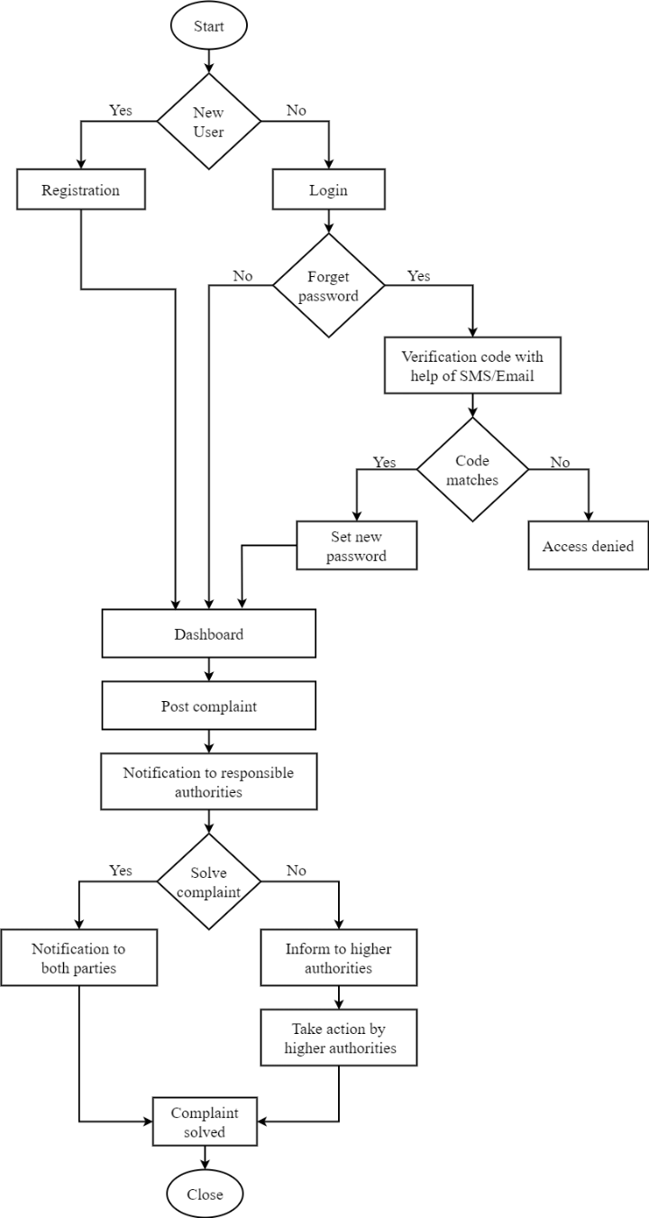

3.2.1: System Flow Diagram for Road Maintenance System

(Group Study, 2023)

### E-R diagram

E-R Diagram stands for Entity Relationship Diagram, also known as ERD is a diagram that displays the relationship of entity sets stored in a database. In other words, ER diagrams help to explain the logical structure of databases. ER diagrams are created based on three basic concepts: entities, attributes and relationships. ER Diagrams contain different symbols that use rectangles to represent entities, ovals to define attributes and diamond shapes to represent relationships. [24]

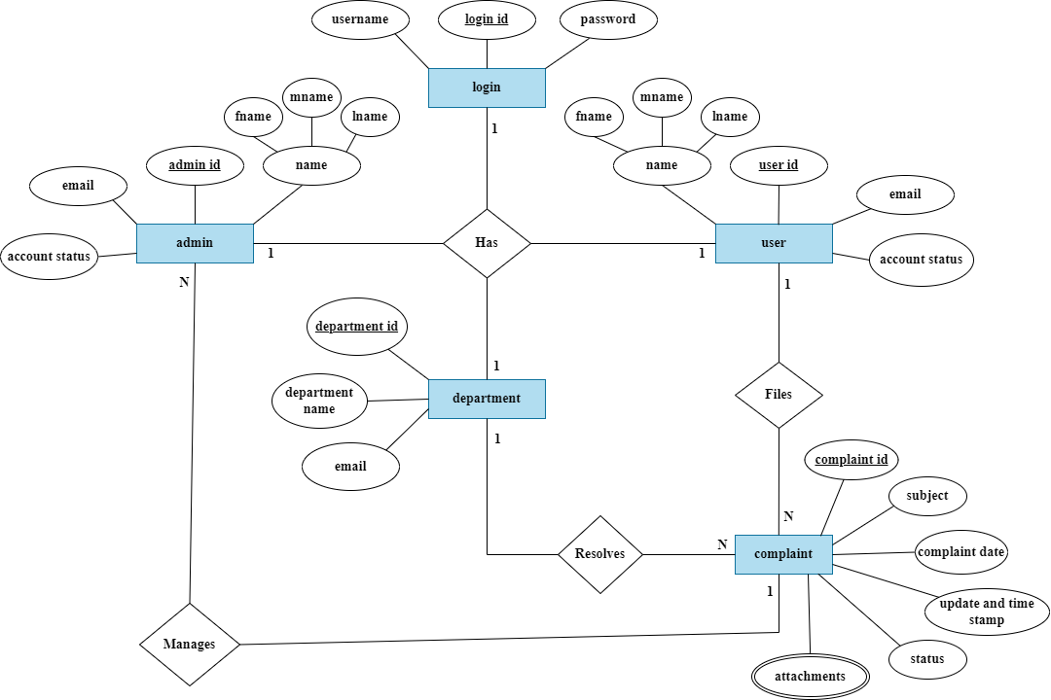

3.2.2: E-R Diagram for Road Maintenance System

(Group Study, 2023)

### DFD (Data Flow Diagram)

Data Flow Diagrams (DFDs) are important tools for our Road Complaint Maintenance System project. DFDs visually show how data moves in our system, helping us find and fix issues to make it work better (Reference: Source). They give us a clear picture of how our system is built and what it does, making it easier for our team to work together (Reference: Source). DFDs can be used at different levels, from big pictures to small details, to help us design and improve our system.

They also help us understand how data connects and moves, ensuring everything works smoothly. By using DFDs in our project, we can improve our understanding, design, and implementation of the Road Complaint Maintenance System [25].

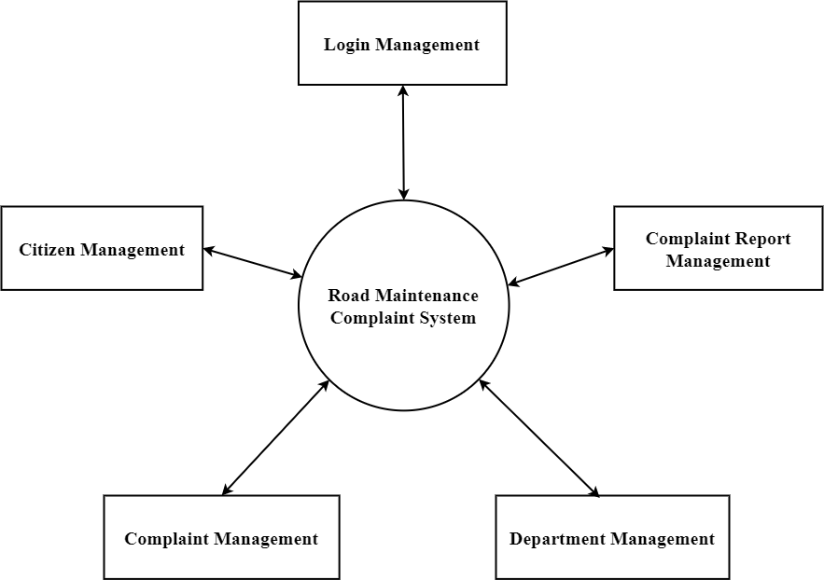

3.2.3: Level 0 Data Flow Diagram

(Group Study, 2023)

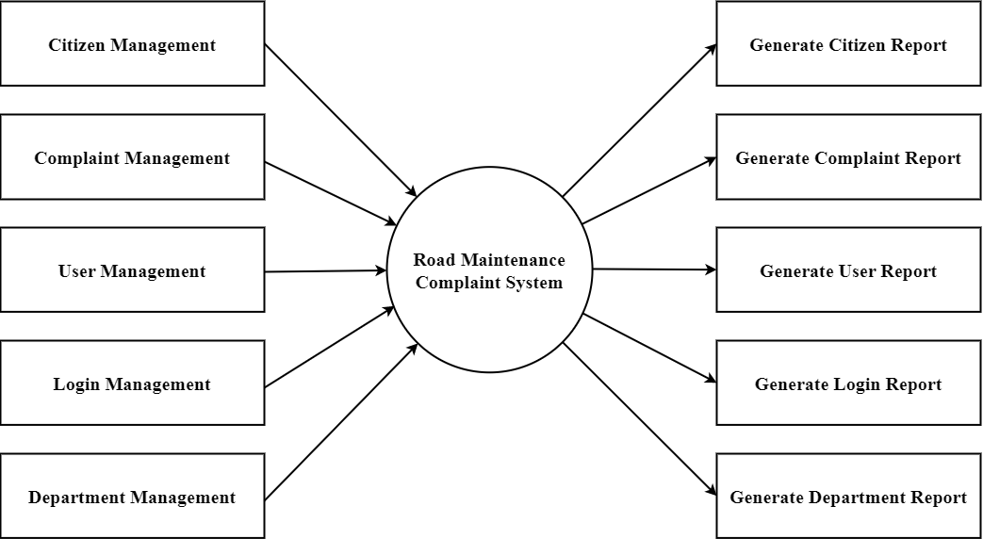

3.2.3: Level 1 Data Flow Diagram

(Group Study, 2023)

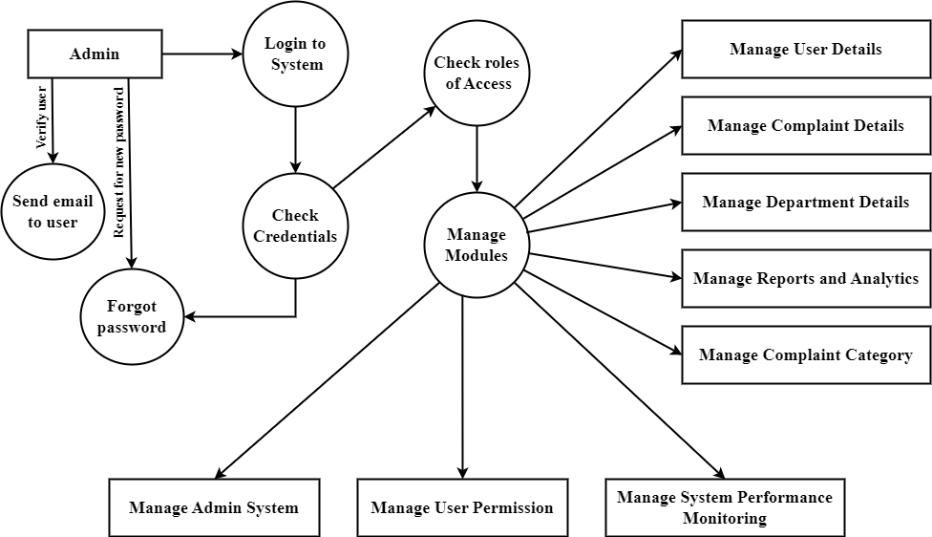

3.2.3: Level 2 Data Flow Diagram

(Group Study, 2023)

### Use case Diagram

A use case diagram is a graphical depiction of a user's possible interactions with a system. A use case diagram shows various use cases and different types of users the system has and will often be accompanied by other types of diagrams as well. [26]

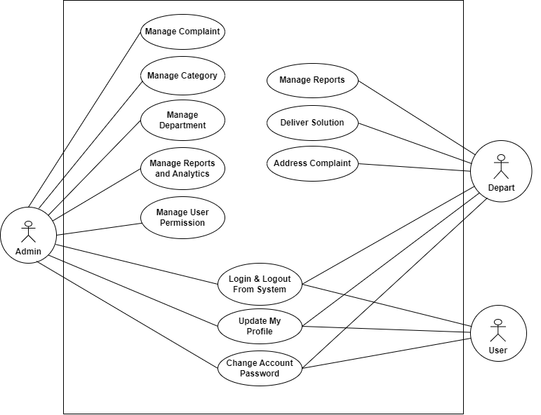

Figure 7: Use case Diagram

(Group Study, 2023)

## 3.2.5 Software Development Model

Through all development stages (analysis, design, coding, testing, deployment), the process moves in a cascade mode. Each stage has concrete deliverables and is strictly documented. The next stage cannot start before the previous one is fully completed. Thus, for example, software requirements cannot be re-evaluated further in development. There is also no ability to see and try software until the last development stage is finished, which results in high project risks and unpredictable project results. Testing is often rushed, and errors are costly to fix.

Fig: Waterfall Model

(Group Study, 2023)

## Testing and maintenance

Before deployment, it is imperative to subject any project to rigorous testing to ensure its adherence to expected behavior. Web applications run on any device that can access the internet which includes desktop computers, tablets, and mobile phones. Web applications are easily scalable, support multiple browsers and devices, platform independent and reduces the cost. It is used for checking the workflows, all the links of the web pages, form testing, cookie testing, and database connection. Ultimately, this testing phase plays a crucial role in mitigating potential issues before the application's release to end users.

**Testing:**

1. **Unit Testing:** Begin with unit testing to test individual components, functions, or modules in isolation. Ensure that each unit performs as expected and handles various input scenarios.
2. **Security Testing:** Perform security testing to identify vulnerabilities and ensure the system is protected against common security threat**s.**

**Maintenance:**

1. **Bug Fixing:** Continuously monitor the system for issues and bugs reported by users.
2. **Update and Enhancements:** Keep the system up to date with the latest technologies and security patches.

# Chapter 4: Time Estimation

The Gantt chart utilized for the management of our project is presented below. This visual representation meticulously outlines the tasks, their respective timelines, dependencies, and critical milestones. This strategic tool has played a pivotal role in guiding and tracking our project's progress, ensuring that each stage was executed in a well-organized and timely manner.

Table 1: Gantt chart of the project

(Group Study, 2023)

|  |  |  |  |  |  |  |  |  |  |  |
| --- | --- | --- | --- | --- | --- | --- | --- | --- | --- | --- |
| Activities | Baisa kh | Jestha | | | | Ashad – Shrawan - Bhadra | | | | Ashoj |
|  | 24th | 1st | 2nd | 3rd | 4th | 1st | 2nd | 3rd | 4th | 1st |
| Literature review |  |  |  |  |  |  |  |  |  |  |
| Preparation of proposal |  |  |  |  |  |  |  |  |  |  |
| Proposal Defense |  |  |  |  |  |  |  |  |  |  |
| Coding initiation |  |  |  |  |  |  |  |  |  |  |
| Mid-Term Presentation |  |  |  |  |  |  |  |  |  |  |
| Coding Continuation |  |  |  |  |  |  |  |  |  |  |
| Report preparation |  |  |  |  |  |  |  |  |  |  |
| Final defense of project |  |  |  |  |  |  |  |  |  |  |

1. **Jestha 1st Week:** During the initial phase of our project, we dedicated considerable time to deliberate and finalize the topic of our project. Once the topic was determined, we proceeded to undertake an extensive review of relevant literature, including project reports, articles, books, and journals, in order to comprehensively understand the existing body of knowledge on our chosen subject.
2. **Jestha 2nd Week:** During the following week, our focus shifted towards preparing a comprehensive project proposal. This stage involved consolidating our research findings, refining the project objectives, and outlining the methodology to be employed.
3. **Jestha 3rd Week:** In the defense, we presented the structured framework of the proposal, showcasing the project's feasibility, resource requirements, and anticipated timeline. We effectively communicate the potential impact and benefits of the project, emphasizing its value to stakeholders.
4. **Jestha 4th -Bhadra 4th Week:** During the period from Jestha 4th to Bhadra 4th week, our primary focus was on coding for our web application. This phase involved the implementation of the project's functionality, user interface, and database integration. We dedicated our efforts to writing and testing the code, ensuring that it aligned with the project's requirements and objectives. Simultaneously, we were aware that we had the mid-term defense scheduled for the 3rd week of Ashad.
5. **Ashoj 1st week:** Last week marked the culmination of our project journey, as we reached the end of the 10th week. By diligently finalizing the project report and adhering to the submission requirements, we aimed to conclude our project successfully and provide a valuable contribution to the respective department. Proper referencing and citation of sources were maintained to uphold academic integrity.

# 

# Chapter 5: Results and Discussion

## Output

The final output of our project was to improve road conditions in Nepal. By implementing our Road Complaint Maintenance System, we aimed to achieve the following:

**1. Efficient Issue Reporting:** Provide a user-friendly platform for citizens to report road problems promptly and accurately.

**2. Timely Response:** Enable authorities to respond quickly to reported issues, leading to prompt repairs and maintenance.

**3. Road Safety Improvement:** Address problems like potholes, damaged signs, and unsafe conditions to enhance overall road safety.

**4. Data Analysis:** Collect and analyze data on reported issues to gain insights for decision-making and future infrastructure developments.

**5.Community Engagement:** Empower citizens to actively participate in road improvement efforts, fostering a sense of community involvement.

**6. Transparency and Accountability:** Ensure visibility and accountability in addressing reported issues, building trust and confidence in the system.

Our project creates an effective system that streamlines issue reporting, enhances road safety, promotes community engagement, and ensures accountability in addressing road-related problems.

## 5.2 Accomplishments:

We are pleased to highlight the noteworthy accomplishments achieved during the development and implementation of the Road Maintenance Complaint System:

1. **Requirement Analysis and System Design:**

Conducted comprehensive requirement analysis by engaging with citizens, including road users, maintenance crews, and government authorities. Designed a robust system architecture based on user requirements, ensuring scalability, modularity, and ease of maintenance.

1. **User Interface Design:**

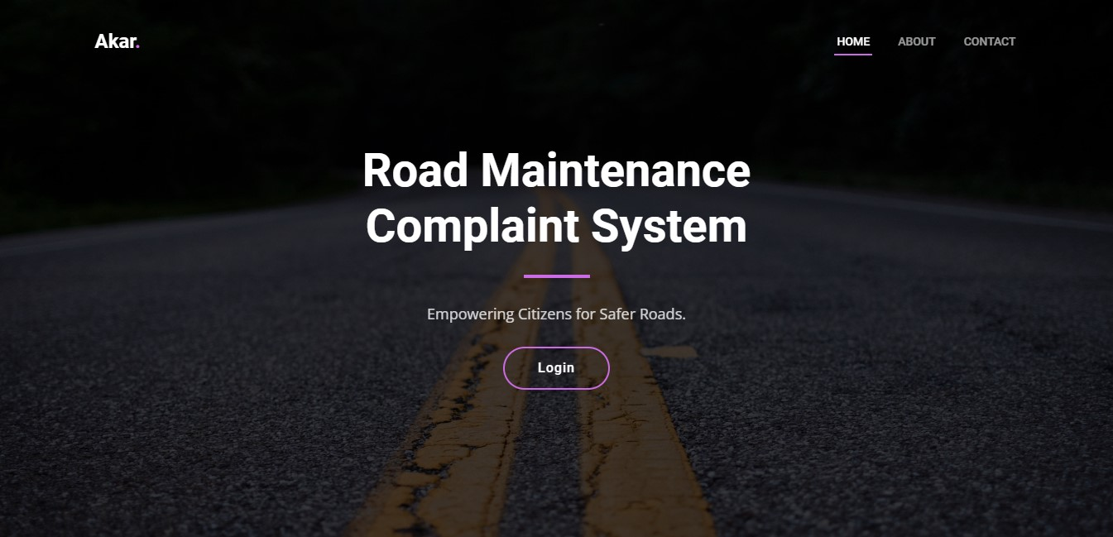

We have accomplished key milestones in our project, including deploying a user-friendly mobile-responsive homepage for the CMS with a basic UI layout, toggle nav bar, header, and footer. Additionally, we have successfully developed a robust web-based platform that allows users to easily report road conditions and maintenance needs through a user-friendly interface.

1. **User Registration Module and Secure Login**

Successfully Implemented a user registration module, allowing road users to create accounts and access the system. After registration users can log in and access their account to complain.

|  |  |
| --- | --- |
|  |  |

1. **User Dashboard:**

Designed and implemented an intuitive dashboard that displays relevant information and metrics, complaint status, account setting, user profile, lodging complaints, and view complaint history.

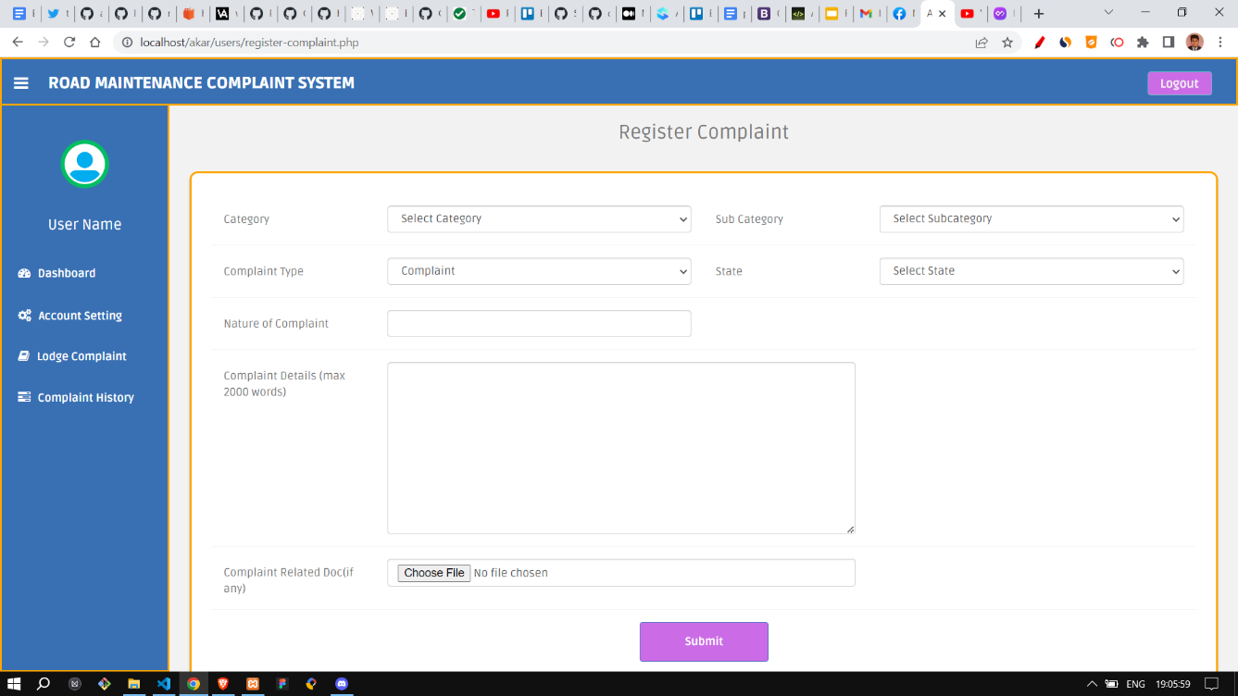

1. **Database Design:**

We have established a comprehensive complaint database that stores and manages all reported issues. This database serves as a central repository of road-related complaints, facilitating efficient tracking and resolution of reported problems.

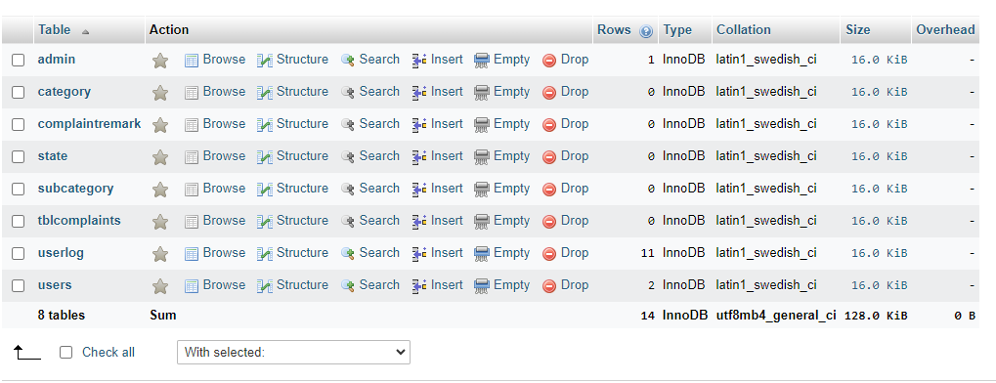

1. **Admin Login**

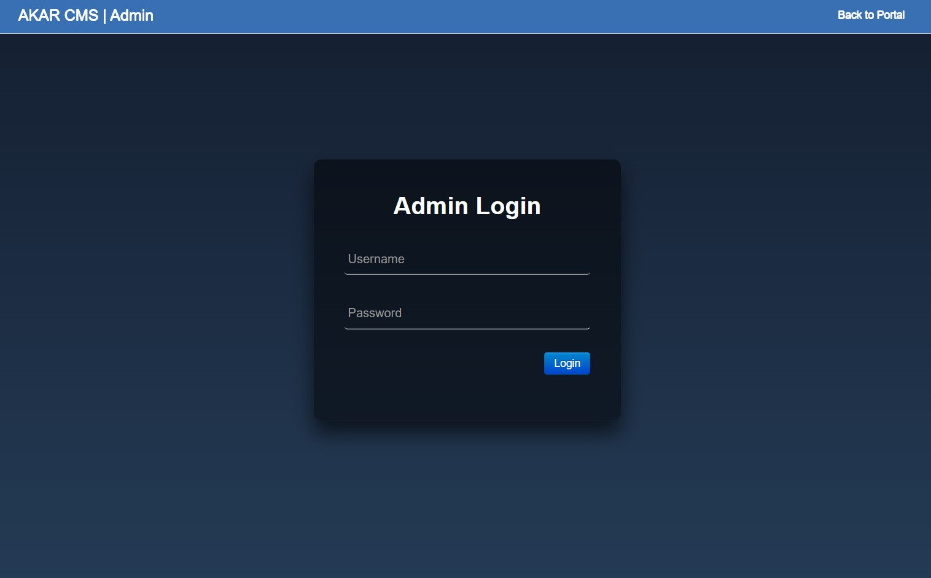

Admin login for authentication process that allows administrators to access the administrative panel or dashboard of a system or application.

1. **Password Reset with Email Verification**

This feature enhances the security and user-friendliness of our system by allowing users to securely reset their passwords when forgotten. It involves the generation and delivery of unique tokens via email, which users can use to reset their passwords, thus improving account recovery processes.

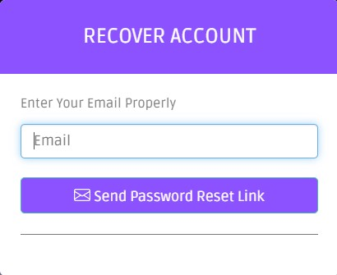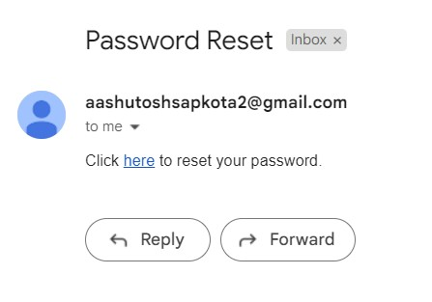

**Token is generated likewise:**

token.png

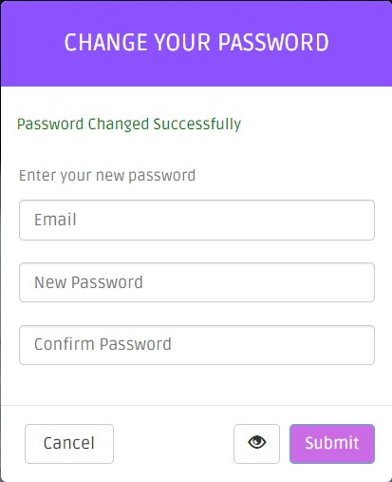

1. **Admin Dashboard:**

The admin dashboard for managing users streamlines administrative tasks, enhances user management efficiency, and ensures proper access control and security within the system or application.

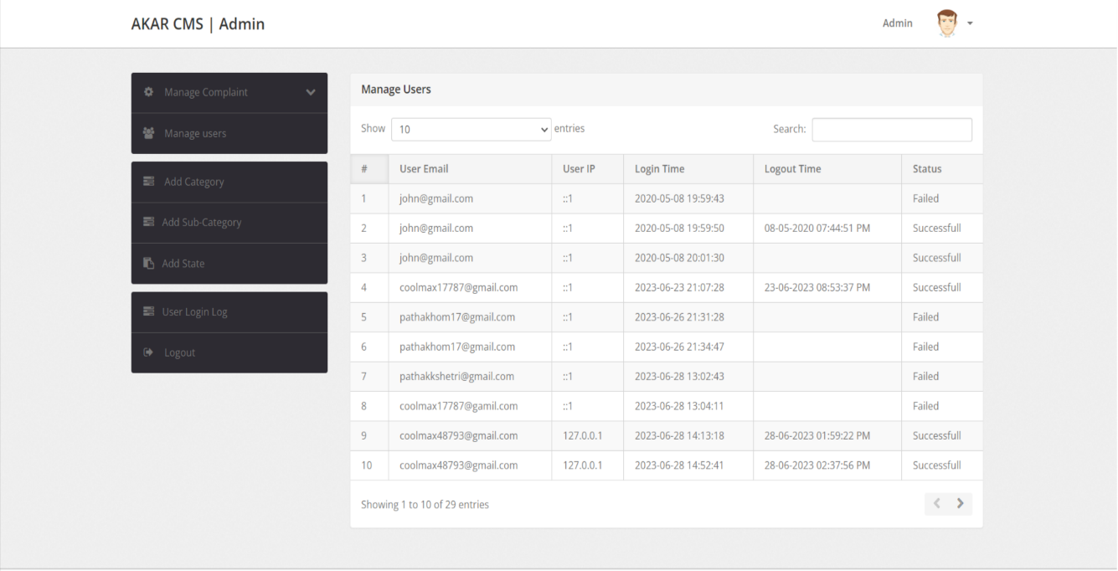

## 5.4 Challenges Encountered:

Throughout the development of the Road Maintenance Complaint Management System, we encountered several challenges that required careful attention and problem-solving. The following challenges were notable during the project:

1. **Spurious Complaint Submissions:**

One of the significant challenges we faced during the development of the Road Maintenance Complaint Management System was the issue of fake complaints inputs. As an open platform accessible to all road users, there was a risk of receiving false or exaggerated complaints, which could lead to unnecessary utilization of resources and hinder the effectiveness of the system.

1. **Scalability and Performance:**

Designing a system capable of handling a growing volume of complaints and users while maintaining optimal performance presented a significant challenge. Extensive performance testing and optimization were required to address potential scalability issues.

1. **Data Privacy and Security:**

Safeguarding user data and ensuring data privacy and security were paramount. Implementing robust security measures, including encryption, access control, and secure communication protocols, demanded meticulous attention to detail and adherence to industry best practices.

## 5.5 Limitation

## Reliability of user-generated data: User-generated data may vary in accuracy and reliability, necessitating validation and verification mechanisms.

## Connectivity and access: Stable internet connection and access to smartphones or internet-enabled devices are necessary for system usage, potentially limiting its effectiveness in areas with connectivity issues.

## 5.6 Budget Estimation

## In the budget estimation for our Road Maintenance Project, it is important to note that we, as Computer Science students, are leveraging our own skills and expertise for the project's development. At this stage, we do not require the involvement of IT professionals. Therefore, the budget primarily encompasses documentation costs, ensuring the thorough and professional documentation of our project's design, development, and implementation.

Table 2: Budget Estimation of the project

|  |  |  |  |  |
| --- | --- | --- | --- | --- |
| Development Activity/Task | Status | Estimated Days | Estimated Hours | Estimated Budget |
| Requirement Analysis | Complete | 7 | 45 | $0 |
| Walk-through & Correction | Complete | 5 | 10 | $0 |
| Domain | Complete | - | - | $0 |
| Hosting | Complete | - | - | $0 |
| DB Design | Complete | 7 | 30 | $0 |
| UI/UX Design | Complete | 6 | 20 | $0 |
| Testing the system | Complete | 5 | 15 | $0 |
| Report writing and final report | Complete | 10 | 10 | $10 |
| **Total Cost** | | 40 | 130 | 1,321.8 NPR. |

(Group Study, 2023)

# Chapter 6: Conclusion & Future Enhancement

## 6.1 Conclusion:

In conclusion, our road complaint management system represents a significant step towards improving road maintenance and safety. Throughout the project, we have made substantial progress in developing a user-friendly platform that empowers citizens to report road issues and actively participate in improving road conditions. We extend our gratitude to all project stakeholders, including government authorities, users, and project team members, for their support and contributions.

## 6.2 Scope of Future Enhancement:

Our road complaint management system has great potential for future enhancements and improvements. Here are some areas where we can expand and enhance the system:

1. **Mobile Application Development:**

Extend the system's functionality by developing dedicated mobile applications for both Android and iOS platforms. This would provide users with more convenience and accessibility, allowing them to report road complaints on the go.

1. **Real-Time Updates and Notifications:**

Implement real-time updates and notifications to keep users informed about the status of their reported complaints. This would enhance transparency and user engagement, providing them with timely feedback on the progress of complaint resolution.

1. **Gamification Elements:**

Introduce gamification elements to incentivize user participation and engagement. For example, users could earn points or badges for reporting accurate and relevant complaints, encouraging active involvement in road maintenance.

1. **Analytics and Reporting Dashboard:**

Develop an analytics and reporting dashboard for government authorities to gain valuable insights from the collected complaint data. This would help identify recurring issues, track maintenance progress, and make informed decisions for road infrastructure improvements.

1. **Expansion to Other Geographic Areas:**

Extend the system's coverage to encompass a broader geographic area, including neighboring cities or regions. This expansion would allow for a more comprehensive approach to road management and better collaboration among multiple local authorities.

By incorporating these future enhancements, our road maintenance complaint system can evolve into a robust and versatile platform that effectively addresses road maintenance challenges, engages users, and contributes to the creation of safer and well-maintained road networks.

# References

|  |  |
| --- | --- |
| [1] | D. N. Chalise, "ROADS BOARD NEPAL: A SUSTAINABLE APPROACH TO ROAD MAINTENANCE MANAGEMENT," *Transport and Communications Bulletin for Asia and the Pacific,* vol. I, p. 81, 2005. |
| [2] | K. Dhakal, "Road Traffic Accidents in Kathmandu Valley," *Journal of Health Promotion,* 2018/11/25. |
| [3] | K. C. B. Adhikary, "Road Traffic Accident and its Characteristics in Kathmandu Valley," *JNMA; journal of the Nepal Medical Association,* vol. 55, 2016. |
| [4] | E. A. Osman Nasr, "ONLINE COMPLAINT MANAGEMENT SYSTEM," *International Journal of Innovative Science, Engineering & Technology,* vol. II, 2015. |
| [5] | P. Kormpho, P. Liawsomboon, N. Phongoen and S. Pongpaichet, "Smart Complaint Management System," *ICT International Student Project Conference,* vol. I, p. 6, 2018. |
| [6] | "GULF TIMES," 3 nov 2017. [Online]. Available: https://www.gulf-times.com/story/569832/Poor-road-conditions-weak-laws-blamed-for-Nepal-tr. [Accessed 22 may 2023]. |
| [7] | ying, "xinhuanet," 1 11 2017. [Online]. Available: www.xinhuanet.com. [Accessed 22 5 2023]. |
| [8] | Frequently Asked Questions, "FixMyStreet," 2007. [Online]. Available: https://www.fixmystreet.com/faq. [Accessed 22 5 2023]. |
| [9] | King and S. F, "Fix my street or else: using the internet to voice local public service concerns," 2007. |
| [10] | Alvin, V. Moere and Andrew, "FixMyStreet Brussels: socio-demographic inequality in crowdsourced civic participation," *Journal of Urban Technology,* vol. 24, 2017. |
| [11] | Roadify team, "Roadify," [Online]. Available: https://roadify.com/. [Accessed 22 5 2022]. |
| [12] | Sagar Mahurkar, Robert Vigeant, Alexander Wald, Sean Watson, "Incorporation of the Roadify API in Ride," 2015. |
| [13] | boston.gov, "Boston," street bumps, 1 7 2019. [Online]. Available: https://www.boston.gov/transportation/street-bump. [Accessed 22 5 2023]. |
| [14] | K. B. M. Noor, "Case study: A strategic research methodology," *American journal of applied sciences,* vol. 5, pp. 1602--1604, 2008. |
| [15] | A. friends and K.Seidler, XAMPP: Simplifying web development with an all in one solution, IEEE Internet Computing. |
| [16] | Microsoft Corporation , A Collaborative Source Code Editor, IEEE Software . |
| [17] | T. Berners-Lee and e. al, "Hypertext Markup Language (HTML)," IEEE Transactions on Communications , 1991. |
| [18] | H. W. Lie and B. Bos, Cascading Style Sheets, IEEE Internet Computing , 1997. |
| [19] | B. Eich, JavaScript: A High-Level, Interpreted Programming Language for Web Development, IEEE Transactions on Software Engineering, 1997. |
| [20] | R. Lerdorf, "PHP: Personal Home Page Tools," 1996. [Online]. Available: https://www.php.net/manual/en/intro-whatis.php. [Accessed 22 5 2023]. |
| [21] | L. E. Ullman, "MySQL 8.0 Reference Manual," 2006. [Online]. Available: https://dev.mysql.com/doc/refman/8.0/en/. [Accessed 22 5 2023]. |
| [22] | Apache Software Foundation community, Apache HTTP Server: An Open-Source Web Server Software, IEEE Software. |
| [23] | J. T. M. Otto, Bootstrap, IEEE Internet Computing. |
| [24] | P. P. Chen, The Entity-Relationship Model: Toward a Unified View of Data, IEEE Transactions on Software Engineering, 1997. |
| [25] | Satzinger and Jackson, Systems Analysis and Design in a Changing World., Boston: MA: Cengage Learning, 2011. |
| [26] | I. Jacobson, Object-Oriented Software Engineering: A Use Case Driven Approach, IEEE Transactions on Software Engineering, 1992. |
|  |  |
|  |  |
|  |  |

## Appendix :

## The source code for the Road Maintenance Complaint System is available on GitHub at the following link:

## <https://github.com/Aashutoshbro/akar>

## This link provides access to the full codebase for the system, including all the PHP scripts, HTML files, and CSS stylesheets.